**OreSat Deployable Antennas**

*Design Review Report*

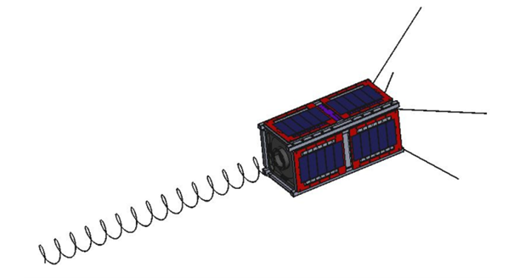

**Team Members**

*Calvin Young*

*Shivani Nadarajah*

*John George*

*Paijanne Jones*

*Justin Burris*

**Sponsors**

*Andrew Greenberg*

*Glenn LeBrasseur*

**ME 493**

*Gerald Recktenwald*

*17 April 2018*

The following page briefly summarizes the team’s recent meeting with its sponsors.

Project Status

* **Helical Antenna:** Design of the antenna itself has been thoroughly worked through and proves satisfactory to Glenn, who oversees the radio-frequency characteristics of the system. The basics of the deployment mechanism has been laid out, though there are many details to work through. Efforts to manufacture the helix were fruitless so the work was outsourced to a local spring manufacturer.
* **Turnstile Antenna**: Multiple functional prototypes have been demonstrated with success. Successive iteration has produced a design that is ready to be machined out of aluminum which will then be subject to more intense scrutiny and testing. Changing requirements from the sponsors may require the addition of more conductive elements to each of the deployed arms, but this will not substantially change the team’s design.
* **Burnwire Mechanisms**: After a successful round of testing burnwires in various configurations at the end of last term, the team and its sponsors are feeling good about the technique. The details of each antenna’s particular deployment configuration still need to be fleshed out, but should not take much time.
* **Vibration Testing**: Last week, the team and its sponsors visited the Dynamics Lab at Hewlett-Packard in Vancouver where we met with an engineer who has been running vibrations tests for over twenty years. He has enthusiastically offered to help with the project (well beyond the capstone). The capstone team will work closely with him to start running vibration tests on each of the antenna subsystems before the end of the term.

Key Client Requirements

* All of the key client requirements (as outlined in previous documents) are still being met or within reach.

Final Deliverables

* **Working System**: The key deliverable of the capstone is a system of two functional antennas each with its own working deployment mechanism.
* **Proven Reliability**: Each system must be shown to work repeatedly in the extremes of the conditions to which it will be subjected.
* **Documentation**: All of the design work and artifacts must be archived on Google Drive and GitHub, where appropriate, in a logical and legible manner.

Budget

* No large purchases have yet been made which leaves the bulk of the budget available for the remaining manufacturing and testing. This includes the helix being made from the spring manufacturer, vibration rigs being machined by outside shops, and the machining and anodizing of the deployment subsystems themselves. Most of the required testing is being offered charitably, though some budget will remain to cover any unforeseen associated costs.